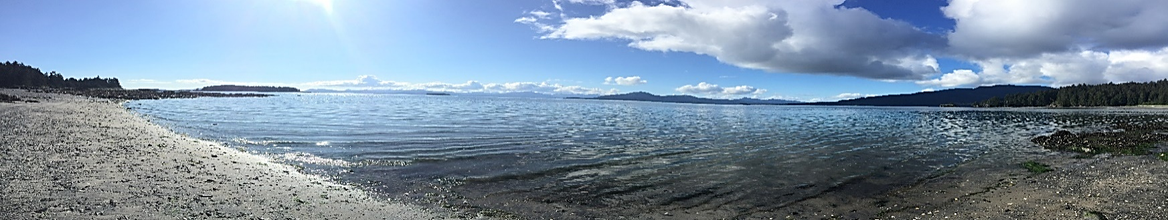

**Light the past spark the future**

**NVA’s Dig Afognak Camp Schedule an Alutiiq Cultural Experience**

These camp offers Alutiiq cultural activities such as the Alutiiq language, art activities, subsistence, traditional beading or skin sewing, spending time with respected Elders, nature walks, healthy friendships, banya a rope course and zip line.

***************************************************************************************************************************************

***Due to CDC Guidelines and to an attempt in keeping our camp COVID-free, we recommend immunizations for children ages 12 and up AND a negative COVID test three prior to attending camp. We are only allowing children in the State of Alaska to attend camp this year, due to the CDC guidelines.***

***Harvesting/Survival Camp July 14th-19th Registration deadline is July 7th***

Participants will take part in traditional subsistence activities with local Elders and adult mentors, harvesting, preparing, and preserving traditional foods. The harvesting and recycling activities are intended to teach youth to protect and preserve our resources for the next generations to come. In addition, youth will learn vital wilderness survival methods through fun outdoor activities, games and competitions. Some of what the participants learn about first aide, exercise using survival techniques, kayak safety, and how to build shelters and fires. Youth ages 9 through 14 are invited $150 for NVA Tribal Members and Descendants/$250 for non-tribal members.

***Afognak Shareholder Camp July 30-August 4th Registration deadline is July 23rd***

*Afognak Native Corporation (ANC) is sponsoring this camp for ANC Shareholders*. Participants are invited to take part in cultural activities such as skin sewing, Alutiiq language, visit with long lost friends, and reminisce while touring the old village of Afognak, if weather permits. Shareholders will have an opportunity to do their subsistence fishing. Shareholder eligibility requirements: Afognak Native Corporation Shareholders plus one guest (guest is defined as an immediate family member); Lineal Descendants of shareholders are allowed to attend as space is available. No shareholder under the age of 15 is able to attend without a responsible adult present at camp; the responsible adult still needs to meet the basic eligibility requirements. We will be holding the Afognak Peoples Picnic on Saturday the 31st at the old village, or camp (weather depending). $125 Per Camper and $50 for those wanting to go on charter boat just for the picnic.

***Koniag Camp August 9-14th Registration deadline August 2nd.***

Koniag is sponsoring this camp for Koniag Shareholders and registered Descendants. Participants are invited to take part in cultural activities such as skin sewing, Alutiiq language and beading. Shareholder/Descendant eligibility requirements: Koniag Shareholders and registered Koniag Descendants. No Shareholder or Descendant under the age of 15 is able to attend without a responsible adult present at camp; the responsible adult still needs to meet the basic eligibility requirements.  This camp is offered at no cost to Koniag Shareholders and registered Descendant who are currently living on Kodiak Island.

**For more information please call the Native Village of Afognak at 486-6357 or email** [**denise@afognak.org**](mailto:denise@afognak.org) **or** [**sierra@afognak.org**](mailto:sierra@afognak.org) **Please prioritize the camps you want to attend, notice of cancellation must be received prior to the registration deadline in order to receive a registration refund.**

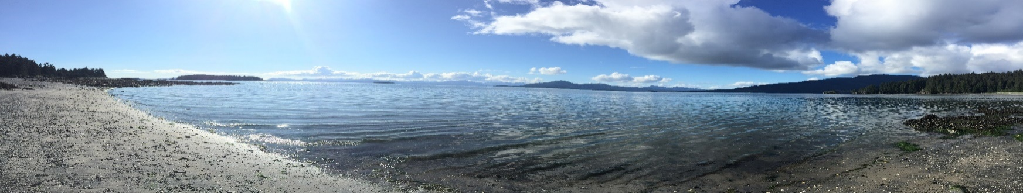

**List of Things to Bring to Camp**

Please clearly mark your bags and personal belongings – Waterproof bag is suggested. Native Village of Afognak is not responsible for damaged, lost, or stolen items.

**************************************************************************************************

**Please Bring:**

Sanitary supplies, Masks you must wear at all times except eating and sleeping

Sleeping bag (we have beds with mattresses)

Pillow

Changes of clothing for at least 6 days, please include clothes that would allow you to dress for the variety of weather that occurs on Kodiak (wind, rain, chilly, or warm). This may include t-shirts, jeans, shorts, sweaters, sweatpants.

Light raingear

Rubber boots & tennis shoes or hiking shoes

Extra socks

Water bottle (we go on lots of hikes)

Insect repellent – aerosol cans are NOT permitted

Sunscreen – aerosol cans are NOT permitted

TWO large towels and TWO wash cloths

Warm jacket

Small day pack

Warm sleepwear

Flashlight

Banya /Personal items – travel size soap, shampoo, deodorant, shower supplies, toothbrush, toothpaste, comb, brush,

Medication (if necessary)…be prepared to provide a medication list including instructions to the Camp Manager upon arrival.

**You may also wish to bring the following:**

Binoculars

Camera

A special skill / craft to share with others

Swimsuit

A musical instrument

Sandals / slip-ons for travels to outhouse and banya

Personal life jacket if you have a favorite (we have plenty)

**Do not bring:**

Pets, Cell phones (they will not work anyway), computers or other electronic devices and games, firearms, explosives, fireworks, etc.

We do allow ipods and music but use is restricted for in the bunks only. No aerosol cans allowed.

Food/Candy – You will not go hungry at camp! Hiding candy or food in bunks might encourage squirrels or even bears to visit!

**If you have questions, please let us know!**

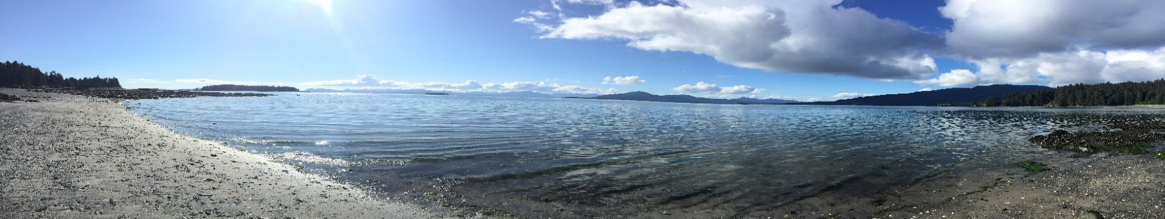

**Camp Registration Form**

2021 Dig Afognak Camp registration fees (per camp) - $150 per NVA tribal members, $250 per non-member

$150 Afognak Shareholder’s Camp payment due with application

Elders and verified KIHA recipients are exempt from all camp fees.

**Please check the box for the camps you plan to attend:**

* **Harvesting/Survival Camp July 14-19th Registration deadline July 7th**
* **Shareholder Camp July 30-August 4th Registration deadline July 23rd**
* **Koniag Camp August 9-14th Registration deadline August 2nd**

Name of Participant___________________________________________________Date of Birth______________Male/Female____

Address _____________________________________________ City _________________State ___________ Zip _______________

Contact Phone Number/s________________________________________E-Mail:_________________________________________

Name of Parent/Guardian____________________________________________________Relation___________________________

Koniag Shareholder ID Number__________________________________________

List Tribes and Native Corporations you or your immediate family are members and/or descendants of: __________________________________________________________________________________________________

There may be financial assistance available to you if your family is or has participated in any of Kodiak Island Housing Authority (KIHA) NAHASDA Assisted Programs. They are the Mutual Help Homeownership Program; the Weatherization Program; the Rental Assistance Programs; the Home Start Program; the Down Payment Assistance Program; and have rented or currently reside in an apartment building owned by KIHA. (This information will be verified by KIHA, additional questions may apply in order to verify eligibility.)

Does your family currently or have in the past participated in a Kodiak Island Housing Authority (KIHA) program?

* YES
* NO

If yes, which program: ________________________________________________________________________________________

If you have any allergies or taking any medications please list them: __________________________________________

_________________________________________________________________________________________________

Physical Abilities: (please initial)

_____I am physically fit to withstand the rigors of an Alaskan wilderness experience where the possibility of inclement weather, travel, manual labor, and camp conditions may pose personal challenge.

Please submit application and payment to: Dig Afognak Camp c/o Native Village of Afognak 115 Mill Bay, Kodiak, Alaska 99615 907-486-6357 • Fax 907-486-6529 or email: [denise@afognak.org](mailto:denise@afognak.org), or [sierra@afognak.org](mailto:sierra@afognak.org)



**Dig Afognak Youth and Parent Agreement**

It is a privilege to attend the Dig Afognak camps and all campers should come with the intention of having fun, learning new things and getting along with everyone.

***************************************************************************************************************************************

Once in a while, there may be a camper who makes camp unpleasant for others because of their harsh words or actions.   If any problems arise, this agreement informs the camper upfront of the potential consequences and holds them accountable for the poor choices they made at camp.

1. I will be polite and respectful to everyone at camp (fellow campers, staff, visitors, presenters, and volunteers).  I will participate in all the activities unless physically unable to do so and the camp manager has agreed with my inability to participate.

2. If someone at camp is bothering or hurting me in any way, I will inform the camp manager immediately so I can concentrate on   having fun and learning.

3. I will try to solve the smaller problems myself by following these choices:

* *Tell them to stop*
* *Walk away*
* *Share and take turns*
* *Ignore it*
* *Talk it out*
* *Apologize*
* *Walk away, wait and cool off*

I have read this agreement and discussed it with my parent/guardian and camper.

I understand that the camper’s parent or guardian may be financially responsible for a boat charter back to Anton’s if these rules and other camp safety rules are not followed.

**My signature is a pledge to follow and support the rules of Dig Afognak at all times.**

______________________________________________________________________Date________________________

Camper Signature

______________________________________________________________________ Date _______________________

Parent/Guardian Signature

**Traveling - Dig Afognak Participant Agreement**

Traveling Dig Afognak Participant Agreement Quyanaa (thank you) for signing up and wanting to participate in our Dig Afognak camps. Dig Afognak will offer you a unique experience that is hard to get at any other camp site. We have been in operation for over 20 years and our continued success is due to eager participants who love to learn. It is our goal to make your travel to and from Kodiak easier and your stay at Dig Afognak a worthwhile experience.

***************************************************************************************************************************************

In order to accomplish this we have set forth a few agreements that need to be made in order for youth coming to Kodiak to have a smooth transition and make sure all of their needs are met.

1. Traveling to and from Kodiak:

i. Parents/guardians are responsible for all travel (airfare or ferry) to and from Kodiak. NVA staff needs copies of travel itineraries at least one week prior to camp starting in order to plan for and confirm participation of your child in Dig Afognak.

ii. Transportation to and from the airport or ferry office: NVA has a limited staff that not only coordinates the logistics of camp but also fulfill normal day to day duties. We can’t guarantee availability of transporting your child to NVA offices or back to the airport/ferry office. We ask that if you have someone in town that can transport your child, you confirm that first, if you have no one else, please confirm with our staff at least one week prior to camp starting.

iii. Getting weathered in Kodiak: Kodiak’s weather is unpredictable throughout the year. Our staff is not equipped to chaperone youth if they get weathered in Kodiak. Please confirm with NVA staff at least one week prior to camp starting as to what your weathered in plan is for your child. We are unable to confirm you child’s participation without this plan in place. In addition, we need all contact information for any adults responsible for your child while in Kodiak.

iv. Food money: please send your child with a little bit of cash to purchase meals or pack snacks ahead of time. Often time’s youth arrive a couple of hours prior to heading to camp and are hungry. If NVA has to purchase meals for your child, you will be responsible for reimbursing NVA once camp is complete.

2. After camp is complete:

i. Lost and found items are collected by camp staff, transported to Kodiak and washed by NVA staff. We hold items for 30 days and all items not claimed after that date will be donated to a local charity.

ii. If your child forgets any items at camp please contact our office immediately. If we are able to locate the lost items we will do our best to get them to you. Any cost incurred by transporting these items will be paid prior to transportation.

I, the undersigned, agree to the terms and conditions set forth in this agreement.

**My signature is a pledge to follow and support the rules of Dig Afognak at all times.**

______________________________________________________________________Date________________________

Camper Signature

_____________________________________________________________________ Date ________________________

Parent/Guardian Signature

**Dig Afognak Camp health and safety guidelines for Camp;**

* Each camper should have more than one clean mask available every day.
* Campers should be outside as much as possible.
* In order to attend Dig Afognak Camp you must be tested before arrival.
* Before you enter any building make sure you have a mask on.

Coronavirus (COVID-19) prevention

COVID-19 most commonly spreads between people who are in close contact through respiratory droplets or small particles produced when an infected person coughs, talks, or breathes. Growing evidence shows that droplets can remain suspended in the air and travel distances beyond six feet, according to the CDC. Indoor environments with poor ventilation increase the risk of transmission.

To prevent infection and to slow transmission of COVID-19, do the following:

* Wash your hands regularly with soap and water or clean them with alcohol-based hand rub.
* Cover your mouth and nose with a mask when in public settings or around others.
* Maintain at least six feet distance between you and people coughing or sneezing.
* Avoid touching your face.
* Cover your mouth and nose when coughing or sneezing.
* Stay home if you feel unwell.
* Practice physical distancing by avoiding unnecessary travel and staying away from large groups of people.

If you have any questions or concerns please let us know. We take the COVID-19 pandemic very seriously; we will follow the latest guidance from the Centers for Disease Control and Prevention. But the vaccine is only available to kids 12 and older, so health precautions are still being recommended. Kids may bring masks and respect social distancing. Dig Afognak will provide masks for all participants.