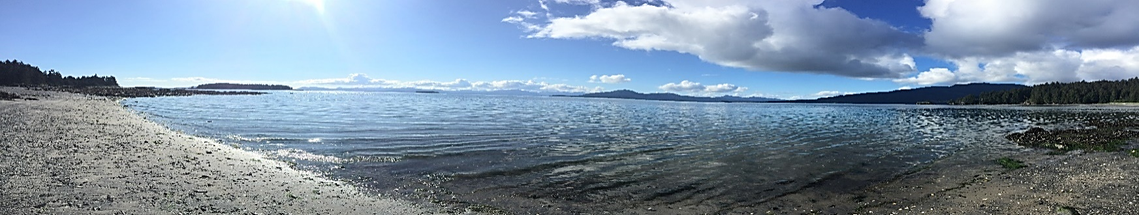

**Light the past spark the future**

**NVA’s Dig Afognak Camp Schedule an Alutiiq Cultural Experience**

These camp offers Alutiiq cultural activities such as the Alutiiq language, art activities, subsistence, traditional beading or skin sewing, spending time with respected Elders, nature walks, healthy friendships, banya, a rope course and zip line.

***Koniag Camp June 24-29th Registration deadline June 17th .***

Koniag is sponsoring this camp for Koniag Shareholders and registered Descendants. Participants are invited to take part in cultural activities such as skin sewing, Alutiiq language and beading. Shareholder/Descendant eligibility requirements: Koniag Shareholders and registered Koniag Descendants. No Shareholder or Descendant under the age of 15 is able to attend without a responsible adult present at camp; the responsible adult still needs to meet the basic eligibility requirements.  This camp is offered at no cost to Koniag Shareholders and registered Descendant who are currently living on Kodiak Island.

***Harvesting/Survival Camp July 13-18th Registration deadline is July 6th***

Participants will take part in traditional subsistence activities with local Elders and adult mentors, harvesting, preparing, and preserving traditional foods. The harvesting and recycling activities are intended to teach youth to protect and preserve our resources for the next generations to come. In addition, youth will learn vital wilderness survival methods through fun outdoor activities, games and competitions. Some of what the participants learn about first aide, exercise using survival techniques, kayak safety, and how to build shelters and fires. Youth ages 9 through 14 are invited $150 for NVA Tribal Members and Descendants/$250 for non-tribal members.

***Language/Music Camp July 22-July 27th Registration Deadline is July 15th***

Youth participants will engage with Elders and culture bearers to learn traditional Alutiiq dance, music, songs, and more. Campers will have the opportunity to play traditional and other instruments and make dance regalia. Participants will apply what they have learned towards creating new and modern expressions that appeal to today’s youth by participating in an evening of camp performances. Youth ages 9 through 14 are invited. $150 for NVA Tribal Members and Descendants/$250 for non-members.

***Afognak Shareholder Camp August 3-August 8th Registration deadline is July 27th***

*Afognak Native Corporation (ANC) is sponsoring this camp for ANC Shareholders*. Participants are invited to take part in cultural activities such as skin sewing, Alutiiq language, visit with long lost friends, and reminisce while touring the old village of Afognak, if weather permits. Shareholders will have an opportunity to do their subsistence fishing. Shareholder eligibility requirements: Afognak Native Corporation Shareholders plus one guest (guest is defined as an immediate family member); Lineal Descendants of shareholders are allowed to attend as space is available. No shareholder under the age of 15 is able to attend without a responsible adult present at camp; the responsible adult still needs to meet the basic eligibility requirements. We will be holding the **Afognak Peoples Picnic on Saturday August 6th** the at the old village, or camp (weather depending). $125 Per Camper and $50 for those wanting to go on charter boat just for the picnic.

**For more information please call the Native Village of Afognak at 486-6357 or email** [**denise@afognak.org**](mailto:denise@afognak.org) **or** [**sierra@afognak.org**](mailto:sierra@afognak.org) **Please prioritize the camps you want to attend, notice of cancellation must be received prior to the registration deadline in order to receive a registration refund.**